**IFT 166 Introduction to Internet Networking**

**Lab 16  
Router Configuration with RIP via the GUI**

* Objectives: create a simple routed WAN with 2 PCs, 2 switches, and 2 routers.
* Identify the proper cable to connect the two PCs to the switches. Identify the proper cables to connect a PC and router to each switch. Identify the proper cable to connect the routers to form a WAN link. Configure workstation IP address information. Test connectivity using the Ping command.

1. Setup the following topology
2. Connect the routers together with a serial DCE cable from each serial ports on the routers

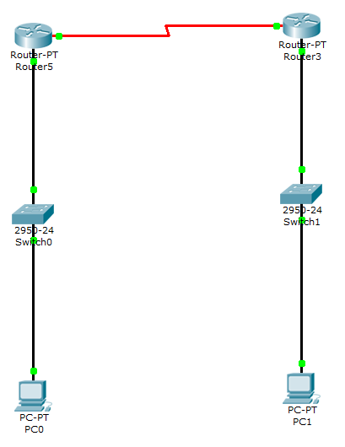

1. Configure the PCs with the following IP address information
2. Include the default gateway s the computers are not directly connected. We essentially have two separate LANs, each connected to its own router.





1. Configure router IP settings on Ethernet ports and serial ports

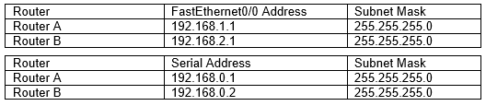

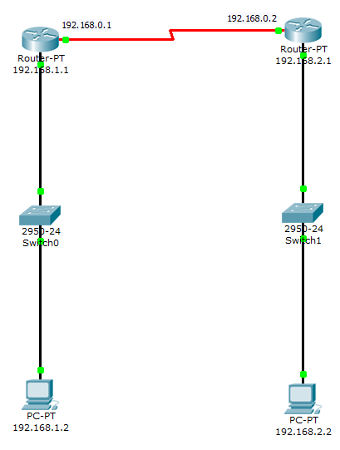

1. Make sure you turn on all ports
2. Make sure the routers are switched on
3. From PC0 (192.168.1.2), ping the default gateway and ping the Router WAN IP (192.168.0.1)
4. From PC1 (192.168.2.1), ping the default gateway and ping the Router WAN IP (192.168.0.2)
5. On PC0, ping PC1, did it work? If not, why not?

We did not setup the router table with IP’s we are using

1. As you just tested, the two routers are not talking to each other. Each router only knows about its two connected networks. They know nothing about the networks on the other side of the other network.
2. We will now enable RIP on both routers so they can update their routing table with their neighbors routing information.
3. Open up Router0 and on the Config tab, click RIP.
4. Add the networks that the router requires routing information. In our example, we have been dealing with networks 192.168.0.0, 192.168.1.0 and 192.168.2.0.

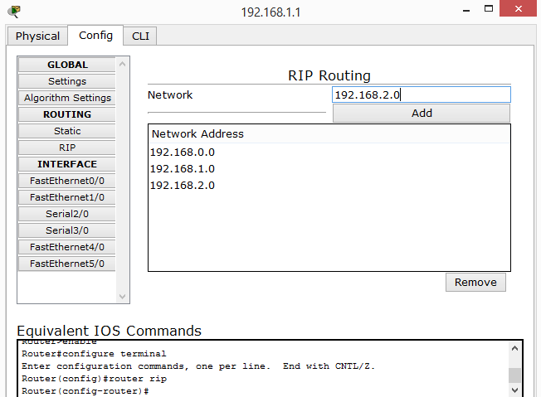

1. Add the same RIP configuration to Router1.
2. On PC0, attempt to ping PC1, did it work?

Yes it did

1. Save the file as ripserial.pkt (no need to email me the file)



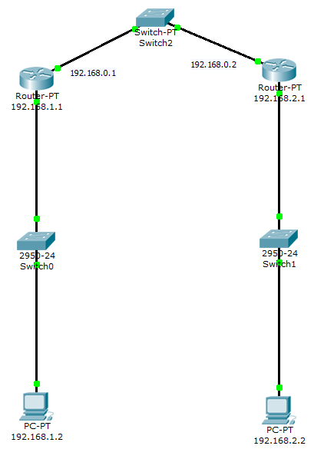

1. Now we will repeat the same scenario, but this time connect the routers together but via switch.
2. You will need to remove the address settings on the serial port and apply them to the FastEthernet ports.
3. Make sure you turn on the ports.
4. Make sure you apply RIP to both routers.
5. From PC0 (192.168.1.2) ping PC1 (192.168.2.2), did it work?

Yes

1. We will now type a command on the router to show the routing table on the routers.
2. Open up Router A and go to the CLI tab and type the command as below.
3. Make sure you type the command ‘show ip route’ in User Mode (Router>). If you are not in this mode, then type exit and hit return till you are back in this mode.

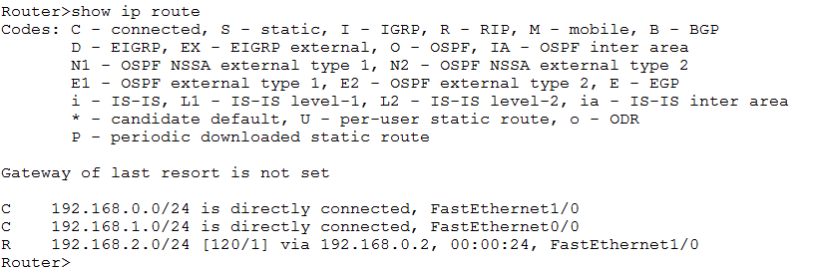

1. Run the command on Router B.

